**BATCH – 24**

**Intelligent Hospital System**

|  |  |
| --- | --- |
| 190031343 | Pothuri Pranitha Varma |
| 190031469 | Sankranti Nitin Bharadwaz |
| 190032121 | Siddharth Verma |

**Homepage**

**Code (HTML)**

<html>

    <head>

        <title> Homepage </title>

        <link rel="stylesheet" type="text/css" href="Home.css"> </link>

        <script type="text/javascript" src="Home.js"> </script>

    </head>

    <body topmargin="0" leftmargin="0">

        <header>

            <img src="Logo.jpg" width="289" height="102" class="logo">

            <div class="dropdown1">

                <button class="dropbtn1"> Register &NoBreak; &#9660; </button>

                <div class="dropdown-content-1">

                    <a href="Doctor-Register.html"> Doctor Registration </a>

                    <a href="Patient-Register.html"> Patient Registration </a>

                </div>

            </div>

            <div class="dropdown2">

                <button class="dropbtn2"> Login &NoBreak; &#9660; </button>

                <div class="dropdown-content-2">

                    <a href="Doctor-Login.html"> Doctor Login </a>

                    <a href="Patient-Login.html"> Patient Login </a>

                </div>

            </div>

            <a href="Home.html"> <button class="home"> Home </button> </a>

        </header>

        <div class="slider">

            <div class="slides">

                <input type="radio" name="radio-btn" id="radio1">

                <input type="radio" name="radio-btn" id="radio2">

                <input type="radio" name="radio-btn" id="radio3">

                <input type="radio" name="radio-btn" id="radio4">

                <div class="slide first">

                    <img src="01.png">

                </div>

                <div class="slide">

                    <img src="02.jpg">

                </div>

                <div class="slide">

                    <img src="03.jpg">

                </div>

                <div class="slide">

                    <img src="04.jpg">

                </div>

                <div class="navigation-auto">

                    <div class="auto-btn1"></div>

                    <div class="auto-btn2"></div>

                    <div class="auto-btn3"></div>

                    <div class="auto-btn4"></div>

                </div>

            </div>

            <div class="navigation-manual">

                <label for="radio1" class="manual-btn"></label>

                <label for="radio2" class="manual-btn"></label>

                <label for="radio3" class="manual-btn"></label>

                <label for="radio4" class="manual-btn"></label>

            </div>

        </div>

    </body>

</html>

**Code (CSS)**

body{

    background-image: url('Background.jpg');

    background-repeat: no-repeat;

    background-attachment: fixed;

    background-size: cover;

}

header {

    background-color: #00a94f;

}

.logo {

    margin-top: 8;

    padding: 1%;

    padding-left: 3%;

}

.dropbtn1, .dropbtn2 {

    background-color: #00a94f;

    color: white;

    border: none;

    padding: 16px;

    font-family: Arial;

    font-size: 16px;

    font-weight: bold;

    cursor: pointer;

}

.dropdown1, .dropdown2 {

    display: inline-block;

    margin-top: 2.75%;

    float: right;

}

.dropdown-content-1, .dropdown-content-2 {

    display: none;

    position: absolute;

    background-color: #f9f9f9;

    min-width: 160px;

    box-shadow: 0px 8px 16px 0px rgba(0,0,0,0.2);

    z-index: 1;

}

.dropdown-content-1 a, .dropdown-content-2 a {

    color: #00a94f;

    padding: 12px 16px;

    font-family: Arial;

    font-weight: bold;

    text-decoration: none;

    display: block;

}

.dropdown-content-1 a:hover, .dropdown-content-2 a:hover {

    background-color: #bfbfbf;

}

.dropdown1:hover .dropdown-content-1, .dropdown2:hover .dropdown-content-2 {

    display: block;

}

.dropdown1:hover .dropbtn1, .dropdown2:hover .dropbtn2 {

    background-color: white;

    color: #00a94f;

    border: 1px solid darkgreen;

}

.home {

    background-color: #00a94f;

    color: white;

    border: none;

    padding: 16px;

    font-family: Arial;

    font-size: 16px;

    font-weight: bold;

    cursor: pointer;

    margin-top: 2.75%;

    float: right;

}

.home:hover {

    background-color: white;

    color: #00a94f;

    border: 1px solid darkgreen;

}

.dropdown1 {

    margin-right: 65px;

}

.dropdown2, .home {

    margin-right: 20px;

}

.slider {

    width: 1500px;

    height: 460px;

    justify-content: center;

    align-items: center;

    overflow: hidden;

    margin-top: 18px;

    margin-left: 18px;

}

.slides {

    width: 1500;

    height: 460px;

    display: flex;

}

.slides input {

    display: none;

}

.slide {

    transition: 2s;

}

.slide img {

    width: 1500;

    height: 460px;

}

.navigation-manual {

    position: absolute;

    width: 300px;

    margin-top: -30px;

    margin-left: 590px;

    display: flex;

    justify-content: center;

}

.manual-btn {

    border: 2px solid #40d3dc;

    padding: 5px;

    border-radius: 10px;

    cursor: pointer;

}

.manual-btn:not(:last-child) {

    margin-right: 40px;

}

.manual-btn:hover {

    background: #40d3dc;

}

#radio1:checked ~ .first {

    margin-left: 0;

}

#radio2:checked ~ .first {

    margin-left: -100%;

}

#radio3:checked ~ .first {

    margin-left: -200%;

}

#radio4:checked ~ .first {

    margin-left: -300%;

}

.navigation-auto {

    position: absolute;

    display: flex;

    width: 300px;

    margin-top: 430px;

    margin-left: 590px;

    justify-content: center;

}

.navigation-auto div {

    border: 2px solid #40d3dc;

    padding: 5px;

    border-radius: 10px;

}

.navigation-auto div:not(:last-child) {

    margin-right: 40px;

}

#radio1:checked ~ .navigation-auto .auto-btn1 {

    background: #40d3dc

}

#radio2:checked ~ .navigation-auto .auto-btn2 {

    background: #40d3dc

}

#radio3:checked ~ .navigation-auto .auto-btn3 {

    background: #40d3dc

}

#radio4:checked ~ .navigation-auto .auto-btn4 {

    background: #40d3dc

}

**Code (JavaScript)**

var counter = 1;

setInterval(function() {

    document.getElementById('radio' + counter).checked = true;

    counter++;

    if (counter > 4) {

        counter = 1;

    }

}, 4000);

**Output**



**Login Page**

1. **Doctor Login**

**Code (HTML)**

<html>

    <head>

        <title> Doctor Login </title>

        <link rel="stylesheet" type="text/css" href="Doctor-Login.css"> </link>

    </head>

    <body topmargin="0" leftmargin="0">

        <header>

            <img src="Logo.jpg" width="289" height="102" class="logo">

            <div class="dropdown1">

                <button class="dropbtn1"> Register &NoBreak; &#9660; </button>

                <div class="dropdown-content-1">

                    <a href="Doctor-Register.html"> Doctor Registration </a>

                    <a href="Patient-Register.html"> Patient Registration </a>

                </div>

            </div>

            <div class="dropdown2">

                <button class="dropbtn2"> Login &NoBreak; &#9660; </button>

                <div class="dropdown-content-2">

                    <a href="Doctor-Login.html"> Doctor Login </a>

                    <a href="Patient-Login.html"> Patient Login </a>

                </div>

            </div>

            <a href="Home.html"> <button class="home"> Home </button> </a>

        </header>

        <form method="get" action="" align="center" onsubmit="return validate();">

            <table width='344px' align='center' class='head'>

                <tr align='center'>

                    <td> <h1> <u> Doctor Login </u> </h1> </td>

                </tr>

                <table align='center' width='344px'>

                    <tr>

                        <td align="center"> <input type='text' name='pid' size="41" id="pid"

placeholder="Doctor ID" class="uname" required > </td>

                    </tr>

                    <tr>

                        <td> <br> </td>

                    </tr>

                    <tr>

                        <td align="center"> <input type='text' name='uname' size="41"

id="uname" placeholder="Username" class="uname" required> </td>

                    </tr>

                    <tr>

                        <td> <br> </td>

                    </tr>

                    <tr>

                        <td align="center"> <input type='password' name='pword' size="41"

id="pword" placeholder="Password" class="pword" required> </td>

                    </tr>

                    <tr>

                        <td align="right" class="forgot"> <a href="#"> Forgot Password? </a>

</td>

                    </tr>

                    <tr>

                        <td> <br> </td>

                    </tr>

                    <tr class="data">

                        <td> <input type="checkbox" name="remember" value="remember">

Remember Me </td>

                    </tr>

                    <table width='344px' align='center' class='tail'>

                        <tr>

                            <td align='center'> <input type='submit' name='login'

value="Login" class='button'></td>

                        </tr>

                        <tr class="data">

                            <td align="center">

                                <br> Not Registered Yet? <a href="Doctor-Register.html">

Register Here </a>

                            </td>

                        </tr>

                    </table>

                </table>

            </table>

        </form>

    </body>

</html>

**Code (CSS)**

body{

    background-image: url('Background.jpg');

    background-repeat: no-repeat;

    background-attachment: fixed;

    background-size: cover;

}

header {

    background-color: #00a94f;

}

.logo {

    margin-top: 8;

    padding: 1%;

    padding-left: 3%;

}

.dropbtn1, .dropbtn2 {

    background-color: #00a94f;

    color: white;

    border: none;

    padding: 16px;

    font-family: Arial;

    font-size: 16px;

    font-weight: bold;

    cursor: pointer;

}

.dropdown1, .dropdown2 {

    display: inline-block;

    margin-top: 2.75%;

    float: right;

}

.dropdown-content-1, .dropdown-content-2 {

    display: none;

    position: absolute;

    background-color: #f9f9f9;

    min-width: 160px;

    box-shadow: 0px 8px 16px 0px rgba(0,0,0,0.2);

    z-index: 1;

}

.dropdown-content-1 a, .dropdown-content-2 a {

    color: #00a94f;

    padding: 12px 16px;

    font-family: Arial;

    font-weight: bold;

    text-decoration: none;

    display: block;

}

.dropdown-content-1 a:hover, .dropdown-content-2 a:hover {

    background-color: #bfbfbf;

}

.dropdown1:hover .dropdown-content-1, .dropdown2:hover .dropdown-content-2 {

    display: block;

}

.dropdown1:hover .dropbtn1, .dropdown2:hover .dropbtn2 {

    background-color: white;

    color: #00a94f;

    border: 1px solid darkgreen;

}

.home {

    background-color: #00a94f;

    color: white;

    border: none;

    padding: 16px;

    font-family: Arial;

    font-size: 16px;

    font-weight: bold;

    cursor: pointer;

    margin-top: 2.75%;

    float: right;

}

.home:hover {

    background-color: white;

    color: #00a94f;

    border: 1px solid darkgreen;

}

.dropdown1 {

    margin-right: 65px;

}

.dropdown2, .home {

    margin-right: 20px;

}

table {

    background-color: white;

    padding: 1%;

    border-left: 2px solid #00a94f;

    border-right: 2px solid #00a94f;

    font-family: Arial;

}

::placeholder {

    color: #00a94f;

    font-weight: bold;

}

.head {

    margin-top: 70;

    color: #00a94f;

    border-top: 2px solid #00a94f;

    padding-top: 25;

    padding-bottom: 0;

}

.tail {

    border-bottom: 2px solid #00a94f;

    padding-bottom: 25;

}

.pid, .uname, .pword {

    padding-left: 10;

    height: 38px;

    border: 1px solid #00a94f;

}

.button {

    background: #00a94f;

    border: 1px solid #00a94f;

    color: white;

    padding: 10px;

    font-size: 15px;

    font-weight: bold;

    padding-left: 5%;

    padding-right: 5%;

    cursor: pointer;

}

.button:hover {

    background: #000066;

    border: 1px solid #000066;

}

.forgot {

    font-size: 13;

}

.data {

    font-size: 15;

}

table a:link, table a:visited {

    color: blue;

}

table a:hover {

    color: red;

}

**Output**

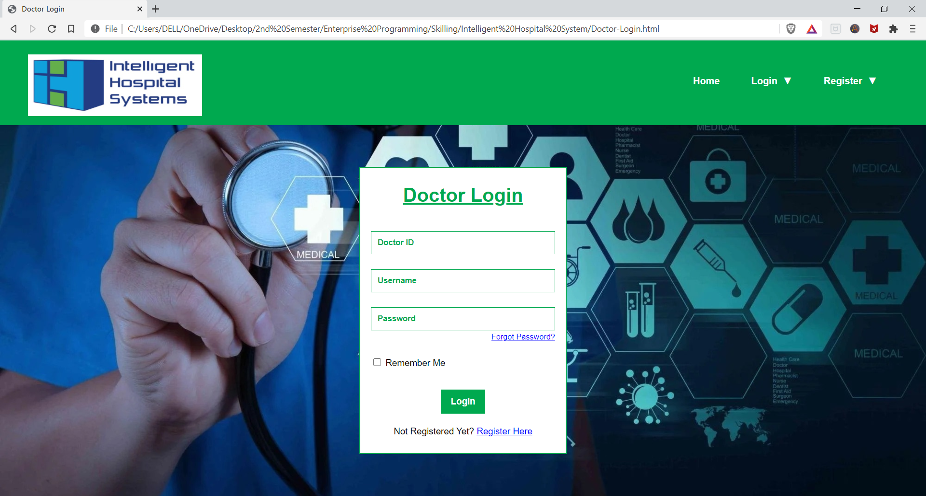

1. **Patient Login**

**Code (HTML)**

<html>

    <head>

        <title> Patient Login </title>

        <link rel="stylesheet" type="text/css" href="Patient-Login.css"> </link>

    </head>

    <body topmargin="0" leftmargin="0">

        <header>

            <img src="Logo.jpg" width="289" height="102" class="logo">

            <div class="dropdown1">

                <button class="dropbtn1"> Register &NoBreak; &#9660; </button>

                <div class="dropdown-content-1">

                    <a href="Doctor-Register.html"> Doctor Registration </a>

                    <a href="Patient-Register.html"> Patient Registration </a>

                </div>

            </div>

            <div class="dropdown2">

                <button class="dropbtn2"> Login &NoBreak; &#9660; </button>

                <div class="dropdown-content-2">

                    <a href="Doctor-Login.html"> Doctor Login </a>

                    <a href="Patient-Login.html"> Patient Login </a>

                </div>

            </div>

            <a href="Home.html"> <button class="home"> Home </button> </a>

        </header>

        <form method="get" action="" align="center" onsubmit="return validate();">

            <table width='344px' align='center' class='head'>

                <tr align='center'>

                    <td> <h1> <u> Patient Login </u> </h1> </td>

                </tr>

                <table align='center' width='344px'>

                    <tr>

                        <td align="center"> <input type='text' name='pid' size="41" id="pid"

placeholder="Patient ID" class="uname" required > </td>

                    </tr>

                    <tr>

                        <td> <br> </td>

                    </tr>

                    <tr>

                        <td align="center"> <input type='text' name='uname' size="41"

id="uname" placeholder="Username" class="uname" required> </td>

                    </tr>

                    <tr>

                        <td> <br> </td>

                    </tr>

                    <tr>

                        <td align="center"> <input type='password' name='pword' size="41"

id="pword" placeholder="Password" class="pword" required> </td>

                    </tr>

                    <tr>

<td align="right" class="forgot"> <a href="#"> Forgot Password? </a>

</td>

                    </tr>

                    <tr>

                        <td> <br> </td>

                    </tr>

                    <tr class="data">

                        <td> <input type="checkbox" name="remember" value="remember">

Remember Me </td>

                    </tr>

                    <table width='344px' align='center' class='tail'>

                        <tr>

                            <td align='center'> <input type='submit' name='login'

value="Login" class='button'></td>

                        </tr>

                        <tr class="data">

                            <td align="center">

                                <br> Not Registered Yet? <a href="Patient-Register.html">

Register Here </a>

                            </td>

                        </tr>

                    </table>

                </table>

            </table>

        </form>

    </body>

</html>

**Code (CSS)**

body{

    background-image: url('Background.jpg');

    background-repeat: no-repeat;

    background-attachment: fixed;

    background-size: cover;

}

header {

    background-color: #00a94f;

}

.logo {

    margin-top: 8;

    padding: 1%;

    padding-left: 3%;

}

.dropbtn1, .dropbtn2 {

    background-color: #00a94f;

    color: white;

    border: none;

    padding: 16px;

    font-family: Arial;

    font-size: 16px;

    font-weight: bold;

    cursor: pointer;

}

.dropdown1, .dropdown2 {

    display: inline-block;

    margin-top: 2.75%;

    float: right;

}

.dropdown-content-1, .dropdown-content-2 {

    display: none;

    position: absolute;

    background-color: #f9f9f9;

    min-width: 160px;

    box-shadow: 0px 8px 16px 0px rgba(0,0,0,0.2);

    z-index: 1;

}

.dropdown-content-1 a, .dropdown-content-2 a {

    color: #00a94f;

    padding: 12px 16px;

    font-family: Arial;

    font-weight: bold;

    text-decoration: none;

    display: block;

}

.dropdown-content-1 a:hover, .dropdown-content-2 a:hover {

    background-color: #bfbfbf;

}

.dropdown1:hover .dropdown-content-1, .dropdown2:hover .dropdown-content-2 {

    display: block;

}

.dropdown1:hover .dropbtn1, .dropdown2:hover .dropbtn2 {

    background-color: white;

    color: #00a94f;

    border: 1px solid darkgreen;

}

.home {

    background-color: #00a94f;

    color: white;

    border: none;

    padding: 16px;

    font-family: Arial;

    font-size: 16px;

    font-weight: bold;

    cursor: pointer;

    margin-top: 2.75%;

    float: right;

}

.home:hover {

    background-color: white;

    color: #00a94f;

    border: 1px solid darkgreen;

}

.dropdown1 {

    margin-right: 65px;

}

.dropdown2, .home {

    margin-right: 20px;

}

table {

    background-color: white;

    padding: 1%;

    border-left: 2px solid #00a94f;

    border-right: 2px solid #00a94f;

    font-family: Arial;

}

::placeholder {

    color: #00a94f;

    font-weight: bold;

}

.head {

    margin-top: 70;

    color: #00a94f;

    border-top: 2px solid #00a94f;

    padding-top: 25;

    padding-bottom: 0;

}

.tail {

    border-bottom: 2px solid #00a94f;

    padding-bottom: 25;

}

.pid, .uname, .pword {

    padding-left: 10;

    height: 38px;

    border: 1px solid #00a94f;

}

.button {

    background: #00a94f;

    border: 1px solid #00a94f;

    color: white;

    padding: 10px;

    font-size: 15px;

    font-weight: bold;

    padding-left: 5%;

    padding-right: 5%;

    cursor: pointer;

}

.button:hover {

    background: #000066;

    border: 1px solid #000066;

}

.forgot {

    font-size: 13;

}

.data {

    font-size: 15;

}

table a:link, table a:visited {

    color: blue;

}

table a:hover {

    color: red;

}

**Output**

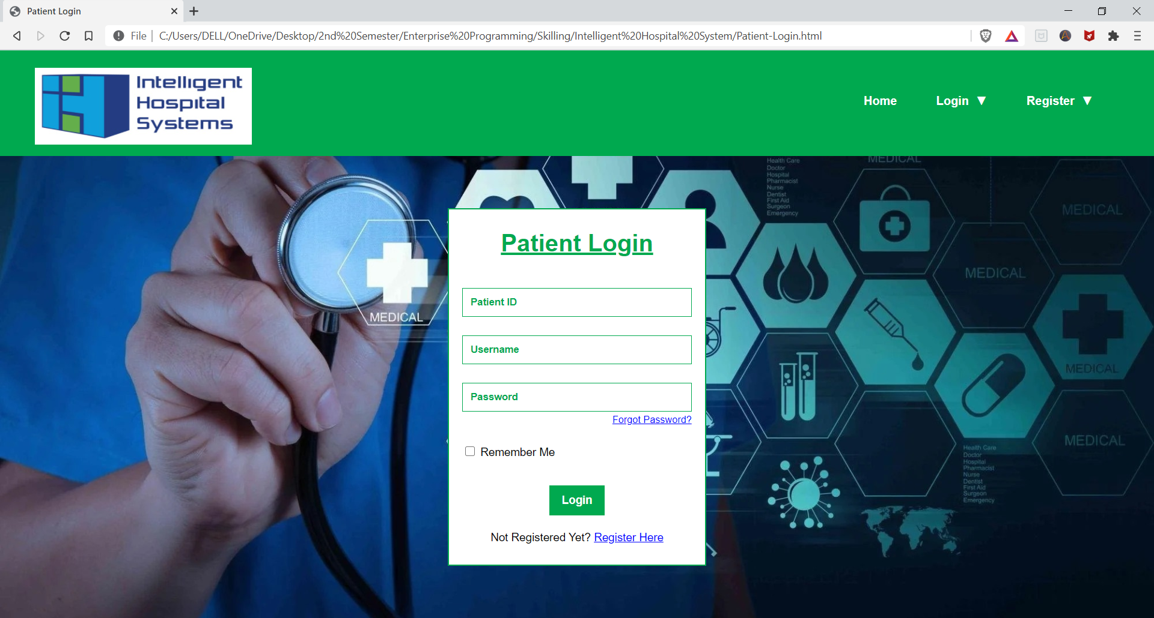

**Sign-Up / Registration Page**

1. **Doctor Registration**

**Code (HTML)**

<html>

    <head>

        <title> Doctor Registration </title>

        <link rel="stylesheet" type="text/css" href="Doctor-Register.css"> </link>

        <script type="text/javascript" src="Doctor-Register.js"> </script>

    </head>

    <body topmargin="0" leftmargin="0">

        <header>

            <img src="Logo.jpg" width="289" height="102" class="logo">

            <div class="dropdown1">

                <button class="dropbtn1"> Register &NoBreak; &#9660; </button>

                <div class="dropdown-content-1">

                    <a href="Doctor-Register.html"> Doctor Registration </a>

                    <a href="Patient-Register.html"> Patient Registration </a>

                </div>

            </div>

            <div class="dropdown2">

                <button class="dropbtn2"> Login &NoBreak; &#9660; </button>

                <div class="dropdown-content-2">

                    <a href="Doctor-Login.html"> Doctor Login </a>

                    <a href="Patient-Login.html"> Patient Login </a>

                </div>

            </div>

            <a href="Home.html"> <button class="home"> Home </button> </a>

       </header>

       <form name="form" method="get" action="" align="center" onsubmit="return validate();">

            <table width='958px' align='center' class='head'>

                <tr align='center'>

                    <td> <h1> <u> Doctor Registration </u> </h1> </td>

                </tr>

                <table width='958px' align='center' cellpadding="3">

                    <tr>

                        <td align="center" colspan="50%"> <input type='text' name='uname'

id='uname' size="64" placeholder="Username" class="constant"

required> </td>

                        <td align="center" colspan="50%"> <input type='email' name='email'

id='email' size="64" placeholder="Email" class="constant"

required> </td>

                    </tr>

                    <tr>

                        <td> <br> </td>

                    </tr>

                    <tr>

                        <td align="center" colspan="50%"> <input type='password' name='pword'

  id='pword' size="64" placeholder="Password" class="constant"

required> </td>

                        <td align="center" colspan="50%"> <input type='password'

name='repword' id="repword" size="64" placeholder="Confirm

Password" class="constant" required> </td>

                    </tr>

                    <tr>

                        <td> <br> <br> </td>

                    </tr>

                    <tr>

                        <td align='center' colspan="98%" class="sub-head"> <h2> Personal

Information </h2> </td>

                    </tr>

                    <tr>

                        <td> <br> </td>

                    </tr>

                    <tr>

                        <td align='center' colspan="98%">

                            <p> <img src="Profile.jpg" id="output" width="200" /> </p>

                            <p> <input type="file" accept="image/*" name="image" id="file"

onchange="loadFile(event)" style="display: none;"></p>

                            <p> <label for="file" class="upload"> Upload Image </label> </p>

                        </td>

                    </tr>

                    <tr>

                        <td> <br> </td>

                    </tr>

                    <tr>

                        <td align="center" colspan="33%"> <input type='text' name='fname'

id='fname' size="40" placeholder="First Name" class="constant"

required> </td>

                        <td align="center" colspan="33%"> <input type='text' name='mname'

id='mname' size="40" placeholder="Middle Name" class="constant">

</td>

                        <td align='center' colspan="33%"> <input type="text" name='lname'

id='lname' size="40" placeholder="Last Name" class="constant"

required> </td>

                    </tr>

                    <tr>

                        <td> <br> </td>

                    </tr>

                    <tr>

                        <td align="center" colspan="33%"> Date of Birth : <input type="date"

name='dob' class="date" required> </td>

                        <td align="center" colspan="33%"> <input type='number' name='age'

id='age' size="40" placeholder="Age" class="age" required> </td>

                        <td align="center" colspan="33%"> <input type='text' name='pob'

id='pob' size="40" placeholder="Place of Birth" class="constant"

required> </td>

                    </tr>

                    <tr>

                        <td> <br> </td>

                    </tr>

                    <tr>

                        <td align="center" colspan="50%">

                            Gender :

                            <input type="radio" name="gender" value="male" required> Male

                            <input type="radio" name="gender" value="female"> Female

                            <input type="radio" name="gender" value="other"> Other

                        </td>

                        <td align="center" colspan="50%">

                            <select name="legal" class="legal" required>

                                <option value="" disabled selected hidden> Are you legally

entitled to work as a doctor in this hospital ?  </option>

                                <option value="YES"> Yes </option>

                                <option value="NO"> No </option>

                            </select>

                        </td>

                    </tr>

                    <tr>

                        <td> <br> </td>

                    </tr>

                    <tr>

                        <td align="center" colspan="33%">

                            Marital Status :

                            <input type="radio" name="marital" value="married" required>

Married

                            <input type="radio" name="marital" value="unmarried">

Unmarried

                        </td>

                        <td align="center" colspan="33%"> <input type='number' name='noc'

id='noc' size="40" placeholder="Number of Children" class="noc"

required> </td>

                        <td align="center" colspan="33%"> <input type='text' name='citizen'

id='citizen' size="40" placeholder="Citizenship" class="constant"

required> </td>

                    </tr>

                    <tr>

                        <td> <br> </td>

                    </tr>

                    <tr>

                        <td align="center" colspan="66%"> <input type='text' name='address'

size="88" placeholder="Address" class="constant" required> </td>

                        <td align="center" colspan="33%"> <input type='text' name='mobile'

id='mobile' size="40" placeholder="Contact No." class="constant"

required> </td>

                    </tr>

                    <tr>

                        <td> <br> </td>

                    </tr>

                    <tr>

                        <td align="center" colspan="33%"> <input type='text' name='position'

id='position' size="40" placeholder="Position Desired"

class="constant" required> </td>

                        <td align="center" colspan="33%"> <input type="number" name='salary'

id='salary' size="40" placeholder="Salary Desired" class="salary"

required> </td>

                        <td align='center' colspan="33%">

                            <select name="time" class="time" required>

                                <option value="" disabled selected hidden> Part-Time /

Full-Time </option>

                                <option value="PART"> Part-Time </option>

                                <option value="FULL"> Full-Time </option>

                            </select>

                        </td>

                    </tr>

                    <tr>

                        <td> <br> <br> </td>

                    </tr>

                    <tr>

                        <td align='center' colspan="98%" class="sub-head"> <h2> Education

</h2> </td>

                    </tr>

                    <tr>

                        <td> <br> </td>

                    </tr>

                    <tr>

                        <td colspan="98%"> High School : </td>

                    </tr>

                    <tr>

                        <td align="center" colspan="66%"> <input type='text' name='college1'

id='college1' size="88" placeholder="Name of the School"

class="constant" required> </td>

                        <td align="center" colspan="33%"> <input type='text' name='location1'

 id='location1' size="40" placeholder="Location" class="constant"

 required> </td>

                    </tr>

                    <tr>

                        <td align="center" colspan="33%"> <input type='text' name='degree1'

id='degree1' size="40" placeholder="Degree" class="constant"

required> </td>

                        <td align="center" colspan="33%"> From : <input type="date"

name='from1' class="date" required> </td>

                        <td align="center" colspan="33%"> To : <input type="date"

name='from1' class="date" required> </td>

                    </tr>

                    <tr>

                        <td> <br> </td>

                    </tr>

                    <tr>

                        <td colspan="98%"> College / University : </td>

                    </tr>

                    <tr>

                        <td align="center" colspan="66%"> <input type='text' name='college1'

id='college1' size="88" placeholder="Name of the College /

University" class="constant" required> </td>

                        <td align="center" colspan="33%"> <input type='text' name='location1'

 id='location1' size="40" placeholder="Location" class="constant"

required> </td>

                    </tr>

                    <tr>

                        <td align="center" colspan="33%"> <input type='text' name='degree1'

id='degree1' size="40" placeholder="Degree" class="constant"

required> </td>

                        <td align="center" colspan="33%"> From : <input type="date"

name='from1' class="date" required> </td>

                        <td align="center" colspan="33%"> To : <input type="date"

name='from1' class="date" required> </td>

                    </tr>

                    <tr>

                        <td> <br> </td>

                    </tr>

                    <tr>

                        <td colspan="98%"> Other : </td>

                    </tr>

                    <tr>

                        <td align="center" colspan="66%"> <input type='text' name='college1'

id='college1' size="88" placeholder="Name of the Institute"

class="constant"> </td>

                        <td align="center" colspan="33%"> <input type='text' name='location1'

id='location1' size="40" placeholder="Location" class="constant">

</td>

                    </tr>

                    <tr>

                        <td align="center" colspan="33%"> <input type='text' name='degree1'

id='degree1' size="40" placeholder="Degree" class="constant"> </td>

                        <td align="center" colspan="33%"> From : <input type="date"

name='from1' class="date"> </td>

                        <td align="center" colspan="33%"> To : <input type="date"

name='from1' class="date"> </td>

                    </tr>

                    <tr>

                        <td> <br> </td>

                    </tr>

                    <table width='958px' align='center' class='tail'>

                        <tr>

                            <td align='center'> <input type='submit' name='login'

value="Register" class='button'></td>

                        </tr>

                    </table>

                </table>

            </table>

        </form>

    </body>

</html>

**Code (CSS)**

body{

    background-image: url('Background.jpg');

    background-repeat: no-repeat;

    background-attachment: fixed;

    background-size: cover;

}

header {

    background-color: #00a94f;

}

.logo {

    margin-top: 8;

    padding: 1%;

    padding-left: 3%;

}

.dropbtn1, .dropbtn2 {

    background-color: #00a94f;

    color: white;

    border: none;

    padding: 16px;

    font-family: Arial;

    font-size: 16px;

    font-weight: bold;

    cursor: pointer;

}

.dropdown1, .dropdown2 {

    display: inline-block;

    margin-top: 2.75%;

    float: right;

}

.dropdown-content-1, .dropdown-content-2 {

    display: none;

    position: absolute;

    background-color: #f9f9f9;

    min-width: 160px;

    box-shadow: 0px 8px 16px 0px rgba(0,0,0,0.2);

    z-index: 1;

}

.dropdown-content-1 a, .dropdown-content-2 a {

    color: #00a94f;

    padding: 12px 16px;

    font-family: Arial;

    font-weight: bold;

    text-decoration: none;

    display: block;

}

.dropdown-content-1 a:hover, .dropdown-content-2 a:hover {

    background-color: #bfbfbf;

}

.dropdown1:hover .dropdown-content-1, .dropdown2:hover .dropdown-content-2 {

    display: block;

}

.dropdown1:hover .dropbtn1, .dropdown2:hover .dropbtn2 {

    background-color: white;

    color: #00a94f;

    border: 1px solid darkgreen;

}

.home {

    background-color: #00a94f;

    color: white;

    border: none;

    padding: 16px;

    font-family: Arial;

    font-size: 16px;

    font-weight: bold;

    cursor: pointer;

    margin-top: 2.75%;

    float: right;

}

.home:hover {

    background-color: white;

    color: #00a94f;

    border: 1px solid darkgreen;

}

.dropdown1 {

    margin-right: 65px;

}

.dropdown2, .home {

    margin-right: 20px;

}

table {

    background-color: white;

    padding: 1%;

    color: #00a94f;

    font-family: Arial;

    font-size: 14;

    font-weight: bold;

    border-left: 2px solid #00a94f;

    border-right: 2px solid #00a94f;

}

.head {

    margin-top: 50;

    padding-top: 25;

    color: #00a94f;

    border-top: 2px solid #00a94f;

}

.tail {

    border-bottom: 2px solid #00a94f;;

    margin-bottom: 50;

    padding-bottom: 25;

}

.sub-head {

    background-color: #00a94f;

    border: 2px solid #00a94f;

    color: white;

    padding-top: 15px;

    padding-bottom: 0px;

}

::placeholder {

    color: #00a94f;

    font-weight: bold;

}

select {

    color: #00a94f;

    font-weight: bold;

    padding-left: 10;

    height: 38px;

    border-width: 1px;

    border-color: #00a94f;

}

.upload {

    cursor: pointer;

    padding: 7px;

}

.upload:hover {

    background-color: #00a94f;

    color: white;

}

.constant, .date, .noc, .age, .salary{

    padding-left: 10;

    height: 38px;

    border: 1px solid #00a94f;

}

.date {

    width: 201px;

}

.legal {

    width: 450px;

}

.time {

    width: 300px;

}

.age, .noc, .salary {

    width: 300px;

}

.button {

    background: #00a94f;

    border: 1px solid #00a94f;

    color: white;

    padding: 10px;

    font-size: 15px;

    font-weight: bold;

    padding-left: 5%;

    padding-right: 5%;

    cursor: pointer;

}

.button:hover {

    background: #000066;

    border: 1px solid #000066;

}

**Code (JavaScript)**

var loadFile = function(event) {

    var image = document.getElementById('output');

    image.src = URL.createObjectURL(event.target.files[0]);

};

**Output**

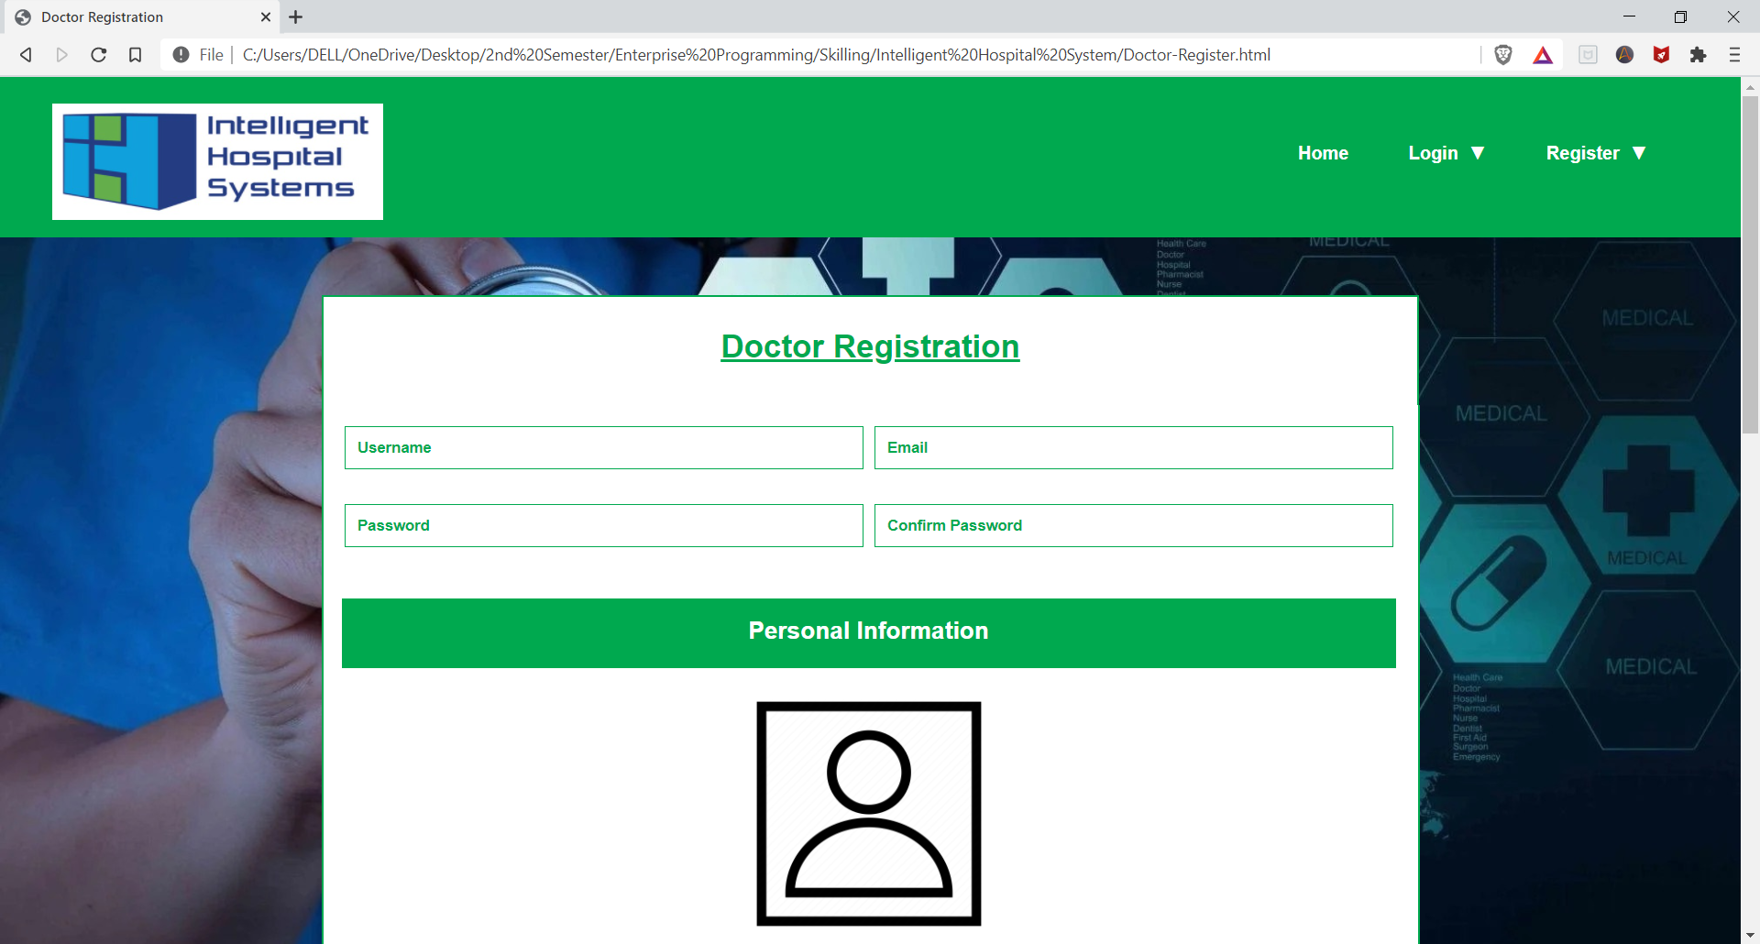

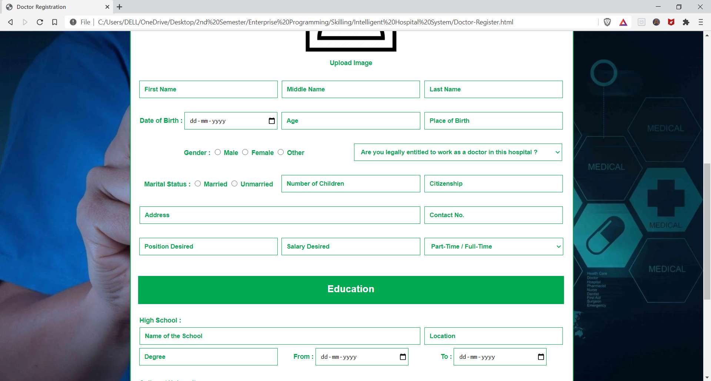

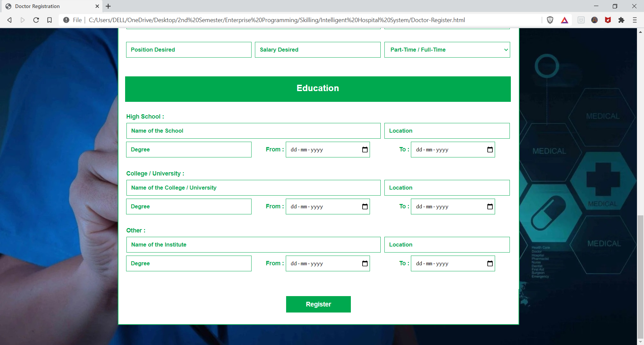

1. **Patient Registration**

**Code (HTML)**

<html>

    <head>

        <title> Patient Register </title>

        <link rel="stylesheet" type="text/css" href="Patient-Register.css"> </link>

        <script type="text/javascript" src="Doctor-Register.js"> </script>

    </head>

    <body topmargin="0" leftmargin="0">

        <header>

            <img src="Logo.jpg" width="289" height="102" class="logo">

            <div class="dropdown1">

                <button class="dropbtn1"> Register &NoBreak; &#9660; </button>

                <div class="dropdown-content-1">

                    <a href="Doctor-Register.html"> Doctor Registration </a>

                    <a href="Patient-Register.html"> Patient Registration </a>

                </div>

            </div>

            <div class="dropdown2">

                <button class="dropbtn2"> Login &NoBreak; &#9660; </button>

                <div class="dropdown-content-2">

                    <a href="Doctor-Login.html"> Doctor Login </a>

                    <a href="Patient-Login.html"> Patient Login </a>

                </div>

            </div>

            <a href="Home.html"> <button class="home"> Home </button> </a>

        </header>

       <form name="form" method="get" action="" align="center" onsubmit="return validate();">

            <table width='650px' align='center' class='head'>

                <tr align='center'>

                    <td> <h1> <u> Patient Registration </u> </h1> </td>

                </tr>

                <table width='650px' align='center'>

                    <tr>

                        <td align="center"> <input type='text' name='uname' id='uname'

size="40" placeholder="Username" class="constant" required> </td>

                        <td align="center"> <input type='email' name='email' id='email'

size="40" placeholder="Email" class="constant" required> </td>

                    </tr>

                    <tr>

                        <td> <br> </td>

                    </tr>

                    <tr>

                        <td align="center"> <input type='password' name='pword' id='pword'

size="40" placeholder="Password" class="constant" required> </td>

                        <td align="center"> <input type='password' name='repword'

id="repword" size="40" placeholder="Confirm Password"

class="constant" required> </td>

                    </tr>

                    <tr>

                        <td> <br> <br> </td>

                    </tr>

                    <tr>

                        <td align='center' colspan="2" class="sub-head"> <h2> Personal

Information </h2> </td>

                    </tr>

                    <tr>

                        <td> <br> </td>

                    </tr>

                    <tr>

                        <td align='center' colspan="98%">

                            <p> <img src="Profile.jpg" id="output" width="200" /> </p>

                            <p> <input type="file" accept="image/*" name="image" id="file"

onchange="loadFile(event)" style="display: none;"></p>

                            <p> <label for="file" class="upload"> Upload Image </label> </p>

                        </td>

                    </tr>

                    <tr>

                        <td> <br> </td>

                    </tr>

                    <tr>

                        <td align="center"> <input type='text' name='fname' id='fname'

size="40" placeholder="First Name" class="constant" required> </td>

                        <td align='center'> <input type="text" name='lname' id='lname'

size="40" placeholder="Last Name" class="constant" required> </td>

                    </tr>

                    <tr>

                        <td> <br> </td>

                    </tr>

                    <tr>

                        <td align="center">

                            <input type="radio" name="gender" value="male" required> Male

                            <input type="radio" name="gender" value="female"> Female

                            <input type="radio" name="gender" value="other"> Other

                        </td>

                        <td align="center"> Date of Birth : <input type="date" name='dob'

class="dob" required> </td>

                    </tr>

                    <tr>

                        <td> <br> </td>

                    </tr>

                    <tr>

                        <td align="center">

                            <input type="radio" name="marital" value="married" required>

Married

                            <input type="radio" name="marital" value="unmarried">

Unmarried

                        </td>

                        <td align="center"> <input type='number' name='age' id='age'

size="40" placeholder="Age" class="age" required> </td>

                    </tr>

                    <tr>

                        <td> <br> </td>

                    </tr>

                    <tr>

                        <td align="center">

                            <select name="occupation" required>

                                <option value="" disabled selected hidden> Select Occupation

</option>

                                <option value="GOVT"> Government </option>

                                <option value="PUB"> Public </option>

                                <option value="PVT"> Private </option>

                                <option value="PROF"> Professional </option>

                                <option value="SE"> Self Employed </option>

                                <option value="STD"> Student </option>

                                <option value="OTH"> Other </option>

                            </select>

                        </td>

                        <td align="center"> <input type='text' name='mobile' id='mobile'

size="40" placeholder="Contact No." class="constant" required> </td>

                    </tr>

                    <tr>

                        <td> <br> </td>

                    </tr>

                    <tr>

                        <td align="center" colspan="2"> <input type='text' name='address'

size="88" placeholder="Address" class="constant" required> </td>

                    </tr>

                    <tr>

                        <td> <br> <br> </td>

                    </tr>

                    <tr>

                        <td align='center' colspan="2" class="sub-head"> <h2> In Case of

Emergency </h2> </td>

                    </tr>

                    <tr>

                        <td> <br> </td>

                    </tr>

                    <tr>

                        <td align="center" colspan="2"> <input type='text' name='name'

id='name' size="88" placeholder="Name of the Person"

class="constant" required> </td>

                    </tr>

                    <tr>

                        <td> <br> </td>

                    </tr>

                    <tr>

                        <td align="center"> <input type='text' name='relation' id='relation'

size="40" placeholder="Relationship with Patient" class="constant"

 required> </td>

                        <td align="center"> <input type='text' name='contact' id='contact'

size="40" placeholder="Person's Contact No." class="constant"

required> </td>

                    </tr>

                    <tr>

                        <td> <br> </td>

                    </tr>

                    <table width='650px' align='center' class='tail'>

                        <tr>

                            <td align='center'> <input type='submit' name='login'

value="Register" class='button'></td>

                        </tr>

                    </table>

                </table>

            </table>

        </form>

    </body>

</html>

**Code (CSS)**

body{

    background-image: url('Background.jpg');

    background-repeat: no-repeat;

    background-attachment: fixed;

    background-size: cover;

}

header {

    background-color: #00a94f;

}

.logo {

    margin-top: 8;

    padding: 1%;

    padding-left: 3%;

}

.dropbtn1, .dropbtn2 {

    background-color: #00a94f;

    color: white;

    border: none;

    padding: 16px;

    font-family: Arial;

    font-size: 16px;

    font-weight: bold;

    cursor: pointer;

}

.dropdown1, .dropdown2 {

    display: inline-block;

    margin-top: 2.75%;

    float: right;

}

.dropdown-content-1, .dropdown-content-2 {

    display: none;

    position: absolute;

    background-color: #f9f9f9;

    min-width: 160px;

    box-shadow: 0px 8px 16px 0px rgba(0,0,0,0.2);

    z-index: 1;

}

.dropdown-content-1 a, .dropdown-content-2 a {

    color: #00a94f;

    padding: 12px 16px;

    font-family: Arial;

    font-weight: bold;

    text-decoration: none;

    display: block;

}

.dropdown-content-1 a:hover, .dropdown-content-2 a:hover {

    background-color: #bfbfbf;

}

.dropdown1:hover .dropdown-content-1, .dropdown2:hover .dropdown-content-2 {

    display: block;

}

.dropdown1:hover .dropbtn1, .dropdown2:hover .dropbtn2 {

    background-color: white;

    color: #00a94f;

    border: 1px solid darkgreen;

}

.home {

    background-color: #00a94f;

    color: white;

    border: none;

    padding: 16px;

    font-family: Arial;

    font-size: 16px;

    font-weight: bold;

    cursor: pointer;

    margin-top: 2.75%;

    float: right;

}

.home:hover {

    background-color: white;

    color: #00a94f;

    border: 1px solid darkgreen;

}

.dropdown1 {

    margin-right: 65px;

}

.dropdown2, .home {

    margin-right: 20px;

}

table {

    background-color: white;

    padding: 1%;

    color: #00a94f;

    font-family: Arial;

    font-size: 14;

    font-weight: bold;

    border-left: 2px solid #00a94f;

    border-right: 2px solid #00a94f;

}

.head {

    margin-top: 50;

    padding-top: 25;

    color: #00a94f;

    border-top: 2px solid #00a94f;

}

.tail {

    border-bottom: 2px solid #00a94f;;

    margin-bottom: 50;

    padding-bottom: 25;

}

.sub-head {

    background-color: #00a94f;

    border: 2px solid #00a94f;

    color: white;

    padding-top: 15px;

    padding-bottom: 0px;

}

::placeholder {

    color: #00a94f;

    font-weight: bold;

}

select {

    width: 300;

    color: #00a94f;

    font-weight: bold;

    padding-left: 10;

    height: 38px;

    border-width: 1px;

    border-color: #00a94f;

}

.upload {

    cursor: pointer;

    padding: 7px;

}

.upload:hover {

    background-color: #00a94f;

    color: white;

}

.constant, .dob, .age {

    padding-left: 10;

    height: 38px;

    border: 1px solid #00a94f;

}

.dob {

    width: 200;

}

.age {

    width: 300;

}

.button {

    background: #00a94f;

    border: 1px solid #00a94f;

    color: white;

    padding: 10px;

    font-size: 15px;

    font-weight: bold;

    padding-left: 5%;

    padding-right: 5%;

    cursor: pointer;

}

.button:hover {

    background: #000066;

    border: 1px solid #000066;

}

**Code (JavaScript)**

var loadFile = function(event) {

    var image = document.getElementById('output');

    image.src = URL.createObjectURL(event.target.files[0]);

};

**Output**

